|  |  |
| --- | --- |
| WEST LONDON WASTE AUTHORITY |  |
| Report of the Treasurer and Managing Director | 22 September 2023 |
| **Finance Report July 2023** | |
| SUMMARY This report provides an update on financial and operational matters. The key points are:   * Day to day financial performance for YTD is showing a deficit largely due to 2 factors * Contracted rates for waste disposal are higher than budgeted * Business rates are significantly higher than budgeted * Tracking return on investments on funded programmes. Spending has not met expectations but direct borough savings are being achieved. We are seeking to do more collaborative working with Boroughs to achieve our year end targets. * Operational performance is shown in the KPIs and is largely on track with one key exception on food waste as lower volumes continue to be collected than anticipated. * There were no delegated decisions to note. * The treasury management information reflects the continuing simple, low risk approach. | |
|  | |
| **RECOMMENDATION(S)**  The Authority is asked to:-   1. Note the current financial position and forecast for 2023/24 2. Note the KPIs to date 3. Note the delegated decisions 4. Note the Treasury Management outturn for 2022/23 and update for 2023/24 | |

1. **Financial position – high level summary**

A summary of the financial performance for the period and forecast to the end of the year is provided over the page. The summary shows how financial performance compares to the budget for both the period and the forecast for the year.



From a year to date activities perspective, the overall performance for the period shows a favourable variance (i.e. underspend) of £7k compared to budget. However, total expenditure is overspent by £1.4m. This is largely due to higher Waste Transfer and Disposal costs reflective of increased prices compared to budget and business rates within Premises costs being higher than budget.

It is also worth noting that the MRF Waste Transfer and Disposal costs are overspent by £782k. This is due to the inclusion of Brent’s contract which was not budgeted. However, this cost is a nil effect to the authority as these costs are directly recovered back from the boroughs. Higher Trade income (recognising £294k more than budget) has contributed to reduce the overall deficit to a surplus.

The first four months of the year have seen slightly higher than budgeted waste volumes. To put in to perspective, levy costs have been 1.5% higher than budgeted to the end of July. Therefore, we have taken a prudent approach and forecasted for a slight increase in volume compared to budget, as we have seen in the first quarter. This has resulted in a forecasted overspend on levies at year end by 0.5%.

There is a overspend in Waste Transfer and Disposal costs which is primarily reflective of higher than budgeted disposal costs.

Employees is also showing a £156k overspend against budget for the full year. This is due to payments made for staff leaving, as well as agency staff used to cover gaps in services.

In June, we presented a deficit of £2.7m for the full year which was partially made up of a higher than budgeted cost for waste treated as ‘deemed landfill’ during the SERC site closure in April. The overall deficit has since reduced to £1.3m, as we have received a £1.5m credit from WLER for the landfill reconciliation for prior years. This has been an ongoing discussion with the contractor for some time, and has only been concluded in recent weeks.

Included within the budget monitoring, is also a disbursement of excess reserves from the previous financial year of £3.3m which was presented in June as part of the 2022/23 draft outturn report.

To note, the excess revenue share from the PPP contract which relates to 2022/23 has now been received (£19.1m). Two thirds of this has been paid to the boroughs in disbursements in July. It is too early to forecast if any excess revenue will come through for 2023/24 through the PPP contract so this has not been forecasted.

The main variances are detailed in the standard breakdown in Appendix 1 which separates out the main types of waste streams and distinguishes between PAYT and FCL activities. Notable items of detail from Appendix 1 include:

Looking at the PAYT waste forecast, the overall residual waste variance of £833k is made up of higher waste tonnages than budgeted for the first 4 months coupled with the higher prices (due to inflation). The higher waste volumes are also reflected in the PAYT levy variance (£336k) which shows actual rebates paid from boroughs to WLWA for higher than budgeted tonnages.

Secondly, in terms of FCL waste, there has been higher than budgeted HRRC volumes leading to higher forecast costs against budget with residual waste making up £178k of the variance.

On a positive note, the level of trade and other income is healthy and forecast to out-perform the budget by £372k.

The forecast for the year for the improvements to borough HRRC’s anticipates investments will be made by the year end.

It should be noted that the waste sector faces a challenging and volatile insurance market. Insurance premiums have been on the rise in recent years. There is a potential in year financial risk of the insurance premium coming in higher than previous years, which has not been budgeted. The costs of repairs caused by the fires, crane malfunction and break-in, are borne by the Contractor, although the Authority bears the risk of insurance premium increases above an agreed level – incidents like this will cause premiums to increase.

1. **KPIs for 2023/24**

Appendix 2 summarises the performance to the end of July, in both a summary table, and significant KPIs being shown graphically with a year on year trend.

Most indicators are on target (green) and the performance is reflected in the RAG rating and commentary. There are two red indicators one being for food waste and the other for sickness days. Lower volumes of food waste tonnages have been collected compared to budget. In terms of sickness days, an employee on long term sick has since returned to work.

Staff turnover is amber due to the outcome being pushed closer to the red threshold in coming months due to known leavers. People development is an amber and this will be monitored to ensure staff are continuing to develop and make a positive impact.

It is worth noting that from time to time the performance for a particular indicator may slip into amber or red, but the performance will be managed and actions undertaken to bring the indicator back to standard during the year. Additionally, given the cumulative nature of each individual indicator, an indicator is more likely to slip into amber or red in the early months.

1. **Delegated decisions**

To provide further transparency of operational arrangements, this standard section of the report summarises any significant financial decisions made since those reported to the last Authority meeting and not reported elsewhere in the agenda.

There have been none to note.

1. **Treasury Management Outturn and Update**

The Authority limits its scale and variety of treasury management activities to simple, low risk and essential operations, as identified in each years’ annual plan.

Essentially excess funds are invested through a service level agreement with Ealing Council with interest being paid annually based on the average return achieved by the borough over the year. The agreement also gives the opportunity for the deposit of funds for fixed periods to enjoy higher rates.

The average interest rate achieved for 2022/23 was 3.4% returning £554k investment income. This is reflective of the interest rates increasing throughout the year, and the high return on short term investments made via Ealing Council. The amount held at year end was £28.0 million.

So far, in 2023/24 operations have been steady and the main change in cash balances is from the receipt of £19.1 excess revenue share income from the PPP contract relating to 2022/23. Two thirds of this income has been passed through to boroughs leaving the Authority with suitable liquidity and reserves to develop projects for managing the risk of upcoming legislative changes.

In terms of borrowings, there have been no changes either last year or this.

For 2022/23 the Authority commenced the year with a total of £85.9 million of repayment loans from four London boroughs and the PWLB. The payments during the year reduced this to a balance of £83.6m by the end of the year.

The interest on borough loans is fixed at 7.604% and the PWLB loan is fixed at 2.24%. 2021/22 saw £5.2m paid in interest.

The key requirements of the CIPFA prudential code is for authorities to ensure that capital expenditure plans are affordable, prudent and sustainable.

It is worth noting that the Authority demonstrates this in its long term financial plans (20 years) which are approved alongside the budget at every January Authority meeting. The plans show:

* balanced annual budgets over the period
* good liquidity is maintained throughout
* all debt is repaid
* all capital expenditure is ultimately charged through levies
* the growth in levies is significantly less than inflation

This provides a complete picture in a typical way used by commercial businesses for long term planning.

The prudential code also prescribes a range of indicators to report. These are more pertinent to public bodies with complex treasury management arrangements and complex long term plans. They are less relevant to Authority’s operations, however the indicators and a brief explanation are provided in Appendix 3. The construction of the Energy from Waste plant accounts for the majority of the value in figures in this appendix.

1. **Impact on Joint Waste Management Strategy***–* Improvements to financial management in the Authority will continue to ensure that the Authority addresses policies of the JWMS.

|  |  |
| --- | --- |
| Contact Officers | Gurdeep Bhogil, Senior Accountant  [gurdeepbhogil@westlondonwaste.gov.uk](mailto:gurdeepbhogil@westlondonwaste.gov.uk)  Sapna Dhanani, Finance Manager  [sapnadhanani@westlondonwaste.gov.uk](mailto:sapnadhanani@westlondonwaste.gov.uk)  Ian O’Donnell, Treasurer  [ianodonnell@westlondonwaste.gov.uk](mailto:ianodonnell@westlondonwaste.gov.uk)  Emma Beal, Managing Director  [emmabeal@westlondonwaste.gov.uk](mailto:emmabeal@westlondonwaste.gov.uk) |

**Appendix 1** 

**Appendix 2**

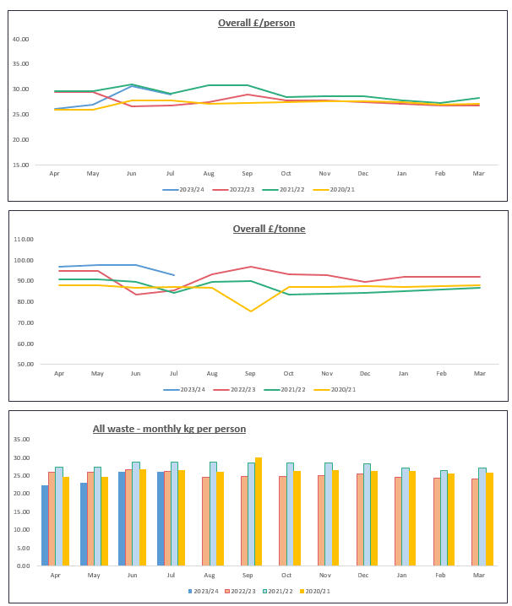

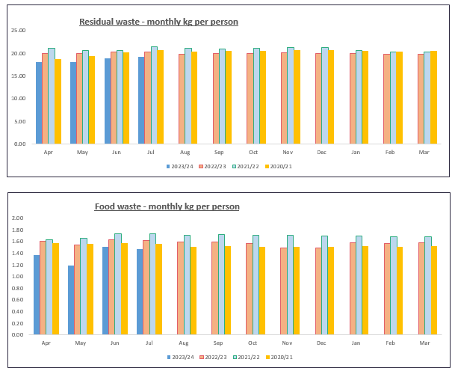

**Appendix 3**

